1. Design a memory map for 256B of RAM (128B per block) and 256B of ROM



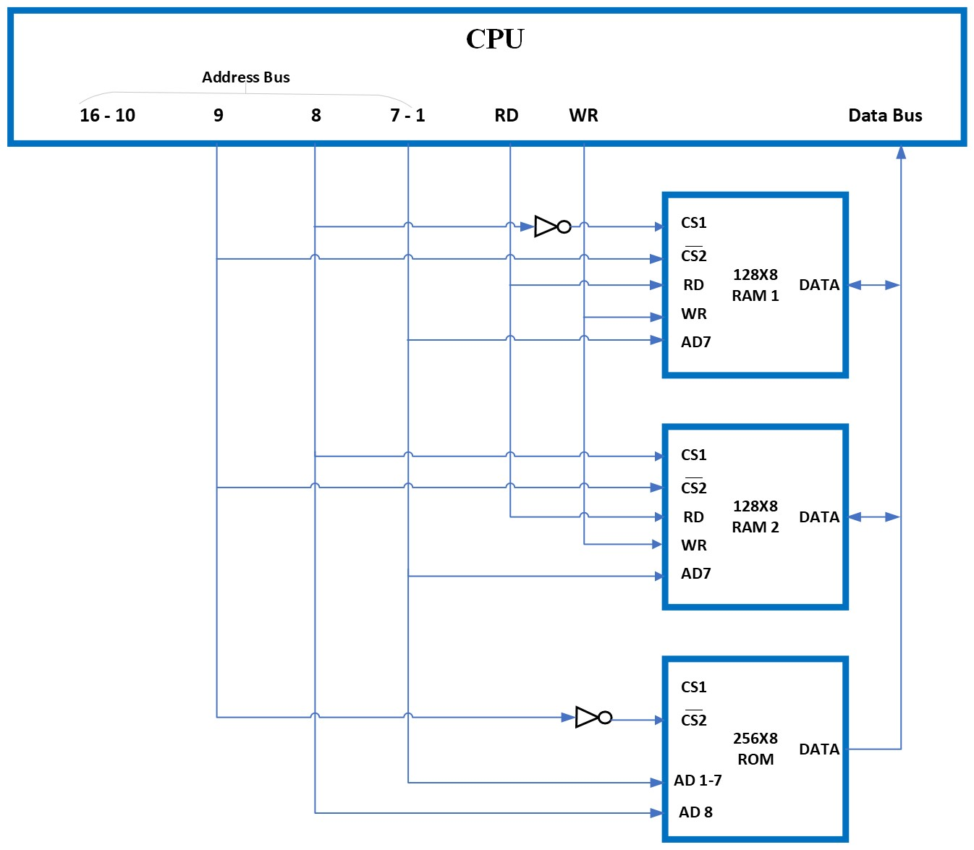

1. Design a memory map for 1024B of RAM (128B per block) and 1024B of ROM



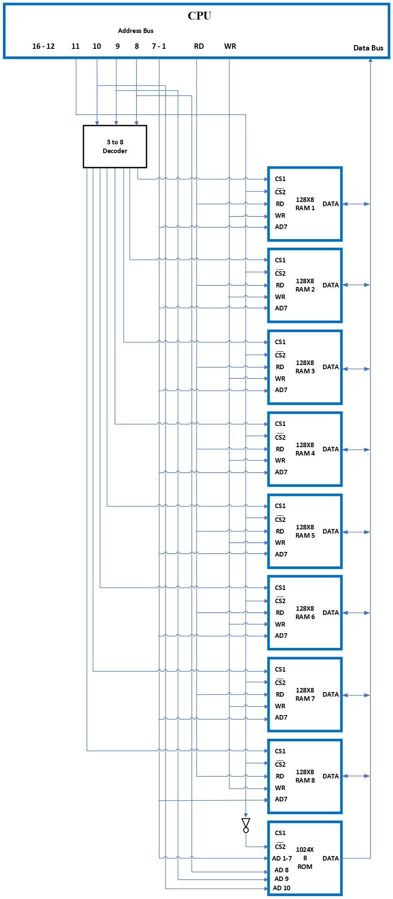

1. Design a memory map for 2048B of RAM (512B per block) and 2048B of ROM



